Career Research

You have started to think about some careers that you might be interested in, and now you are going to begin to research one of those careers to find out more.
With everything we see on television or in the movies, it is easy to form false impressions about certain jobs or careers. Choosing a career is an important decision, and it’s important to have the right information to make that decision.
You will need to find the following information out about one of your chosen careers. You will be creating a report for this career using the following pages as a guided format.
Your completed typed report for your career is due _____________________.

Title of Career
Brief Introduction of the Career
Write 3-5 sentences about the career as an introduction. How would you describe this career to someone who didn’t know very much about it? What do you “do” in this job? What is the purpose of the job?

Job Environment
Will this job require you to work inside or outside? Will you travel, or will you work in one location? Will you work with many people, or by yourself? Will you work with the same people every day, or many different people? Will you work with machines more than people?

Specific Tasks
How will you be spending your time in this job? What percentage of time will you be spending on various tasks? Will you be doing the same thing over and over again, or is there variety to the duties of this job?

Working Hours and Conditions
Will you work a regular, 40-hour workweek? Will you work days, nights, weekends? Will you be required to work overtime often? Is there stress involved with this job? Are the working conditions safe, or hazardous in some ways?

Typical Salary
What is the typical beginning salary? Does the salary increase with years of experience? What kinds of increases in salary might be expected?

Education and Training
Does this career require a high school diploma, a college degree, or an advanced degree? Is on-the-job training provided? Does it require a certificate or license? Do you have to pass any tests to attain that certificate or license? Are you expected to continue your education and training once you enter into this career?

Special Skills and Abilities
Are there any special physical skills required to do this job? Any special talents or abilities? Is the field so competitive that only a few people with specialized talents may enter it?

Physiological Requirements
Are there any special demands on your body such as sitting, standing, or working on a computer for long periods of time?

Personal Characteristics
Are certain personal or personality characteristics desirable, such as friendliness with new people or the ability to work unsupervised?

Advantages or Rewards
What about this job would be stimulating or rewarding to you? What would be its greatest advantages to you?

Disadvantages or Drawbacks
What could be disadvantages to this career? What might be a drawback for you?

Classes to Take Now
What courses are available to you now and in high school that will help you prepare for this career? What other experiences might you have through school (such as clubs, sports, etc.) or outside of school in the community that could help you develop the skills and abilities for this career?

Classes to Take in College
What classes should you take in college to prepare you for this job? What kind of majors/degrees would be most helpful to have for this job?

Conclusion
Do you think that you meet the requirements for this job? Does this job fit your values, strengths, and personality traits? Would this job meet the lifestyle and budget needs you anticipate? What are the strengths you bring to a job like this?

- Begin by looking at www.collegeboard.org

- Click on “College Planning” at the top

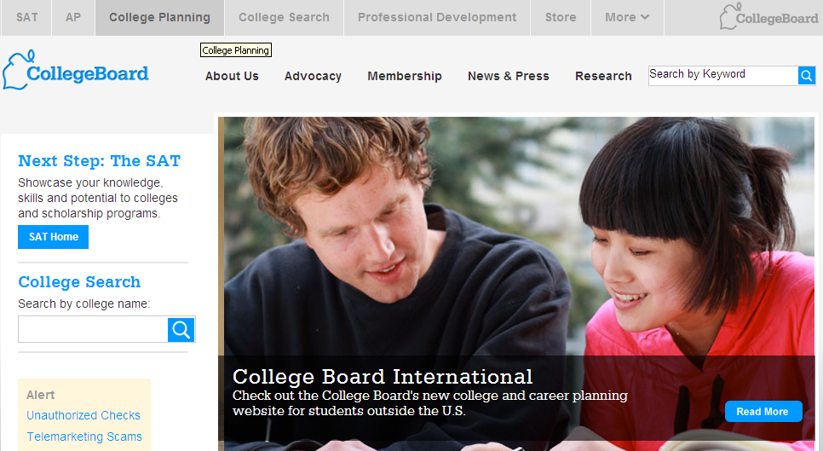

- Under the red “Find a College”, click on “Careers and Majors”

- You will see a list of categories

- Select a career from the list on the right. You will then see a list of jobs that fall under that category. Click on one. You will then see a lot of information about that career:

- Also, you might want to begin saving information in a Word Document once you get it. Write your report as you go!

Please note that your final drafts of your Career Research Reports are due typed in the correct format on Wednesday, March 14th.

Format:
1” margins
12 point font (Times New Roman or Arial)

*See example

Mrs. Todd

14 March 2012

Period 1 & 6

AVID

Career: English Teacher

Brief Introduction of Career:
An English teacher works in either public or private schools for grades 6-12. She is responsible for teaching literature, grammar, writing and reading. Since all students have to take English all 4 years of high school, English teachers are in great demand. An English teacher designs lessons from standards and the given curriculum and comes up with ways to teach her students in a way that makes it easy to learn.

Job Environment:

